Investigation of Approach Flow Parameters, Scaling Factors, and Measurement Accuracy on Film Cooling Effectiveness and Heat Transfer Coefficient Augmentation

Doctoral Dissertation Proposal
Joshua B. Anderson

Department of Mechanical Engineering
The University of Texas at Austin
August 2016

Objectives of this Investigation
This work will provide a consolidated and clear description of the influence of approach flow and coolant flow parameters on film cooling performance for gas turbine applications. This will be accomplished in the following ways:
- Parametrically vary the film cooling flow parameters including the blowing ratio (M), momentum flux ratio (I), and velocity ratio (VR) across different density ratio values of DR = 0.95 – 2.0. This study will consider shaped film cooling holes fed by a quiescent plenum. Measurements will include adiabatic effectiveness, thermal fields above the wall, and velocity fields of the coolant flow. A method of correcting the effects of DR will be proposed as well.

- Parametrically vary the Mach number, Reynolds number, boundary layer thickness, and turbulence characteristics of the freestream flow approaching a film cooling jet in order to understand the influence of each parameter on film cooling. Adiabatic effectiveness measurements and heat transfer coefficient augmentation are the primary measurement methods to be used, and thermal fields and velocity fields will be utilized to further investigate parameters which show a strong effect.

- Evaluate carefully the experimental measurement and data reduction methods utilized to measure the local adiabatic wall temperature. In thermal film cooling measurements, lateral conduction between coolant jets and thru-wall conduction in the model are unwanted phenomena which cause experimental errors. Radiation exchange within the wind tunnel facility also causes similar problems. This is a pressing current issue in film cooling experiments and design. Some methods of removing or correcting for these effects have been proposed, and these methods will be experimentally validated using thermal fields and surface temperature measurements.

Nomenclature

AR shaped hole area ratio
Bi Biot number
CA/SH Compound-angle shaped hole
D film coolant hole diameter (when capitalized)
d diameter other than film cooling hole
dP differential pressure
DR density ratio, $ρ_{c}/ρ_{∞}$
EDM electric discharge machining
H boundary layer shape factor, δ*/ θ
HTC heat transfer coefficient
h heat transfer coefficient
I momentum flux ratio, $ρ_{c}U_{c}^{2}/ρ_{∞}U_{∞}^{2}$
k thermal conductivity
l film cooling hole length
M blowing ratio, $ρ_{c}U_{c}/ρ_{∞}U_{∞}$
Ma Mach number, $\sqrt{γRT}$
p film cooling hole pitch spacing
P static pressure
PR coolant static pressure ratio, $P_{c}/P_{∞}$
q heat flux
Re_{D} Reynolds number, $ρ_{∞}U_{∞}D/μ_{∞}$
T temperature
U mean velocity
VR velocity ratio, $U_{c}/U_{∞}$
Tu turbulence intensity, $u_{RMS}/\overline{u}$
t thickness
x streamwise coordinate (downstream edge of hole breakout x = 0)
y wall-normal coordinate (wall is y = 0)
z lateral coordinate

Greek
α hole surface injection angle
β shaped hole lateral expansion angle
γ film cooling compound injection angle
δ boundary layer thickness; uncertainty in measured quantity; shaped hole forward expansion angle

Δ difference
η adiabatic effectiveness, $(T_{∞}-T_{aw})/(T_{∞}-T_{c})$
θ off-wall effectiveness $(T_{∞}-T_{probe})/(T_{∞}-T_{c})$
ϕ overall cooling effectiveness $(T_{∞}-T_{w})/(T_{∞}-T_{c})$
Λ_{x} turbulence integral length scale
μ dynamic viscosity, curve fit to NIST data

SUBSCRIPTS, ACCENTS
99 “99%” boundary layer thickness location
0 without/no film cooling
aw adiabatic wall
b bias uncertainty
c pertaining to coolant
CL centerline value
D cooling hole diameter
f with film cooling
m metering hole
p precision uncertainty
probe referring to the thermal field probe
th thermal
w wall
laterally-averaged value
area-averaged value
* displacement thickness
∞ freestream value

Film Cooling Fundamentals
Gas turbine-based energy conversion is an extremely important technology in the modern world, enabling high-speed air travel and environmentally-friendly electricity generation. As electricity producers continue to seek alternatives to coal-based power generation, highly-efficient natural gas power plants will become a larger proportion of the fuel mix in the coming decades. For aviation, increasing the efficiency of aircraft engines enables airline fleets to reduce their fuel costs as well as decrease pollutant production. The gas turbine has been the subject of extensive research since its invention, and advances in the efficiency, durability, and flexibility of these engines continue today at a rapid pace.
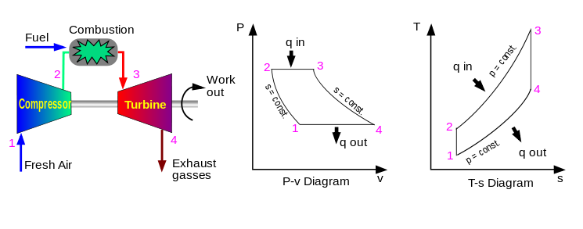
All practical gas turbine engines utilize the open Brayton Power Cycle, a greatly simplified version of which is shown below in Figure 1. Air enters the compressor at Location 1 where the pressure is increased up to P₂ = 60 times that of the ambient air (T₂ ≈ 800-900°C). Fuel is added at Location 2, with the resulting combustion raising the temperature of the air as high as T₃ = 1,800-2,000°C at Location 3. The combustion gasses are then expanded through the turbine, producing work, a portion of which drives the compressor, and the remainder of which can be used to drive either an electric generator or propulsion equipment (fan, propeller, or marine drive).
Figure 1: Components and thermodynamic processes of a simple open Brayton Cycle.

A thermodynamic analysis of the Brayton cycle [1] shows that the maximum cycle efficiency can be increased by increasing the pressure ratio of the engine or temperature ratio as shown in equation 1:
$$η_{th,max}=1-\frac{T_{1}}{T_{3}}=1-{\left(\frac{P_{1}}{P_{3}}\right)}^{\frac{γ-1}{γ}}$$ | (1)
While there are no engines that operate at this maximum efficiency, this value serves as a ceiling for the possible efficiency that can be obtained for a given engine design. From this perspective, it is therefore desirable to increase the temperature of the air entering the turbine as much as possible. The components of the turbine must also be able to withstand exposure to the extreme temperatures of the combustion gases. No practical materials capable of operating at these temperatures exist; instead, a number of cooling technologies are employed to increase the lifetime of turbine components, enabling use of extant materials. While there are many methods of turbine temperature control, including internal convective cooling and external thermal-barrier coatings (TBC), this work is focused on film cooling, which is an external convective heat transfer method for reducing metal temperatures.
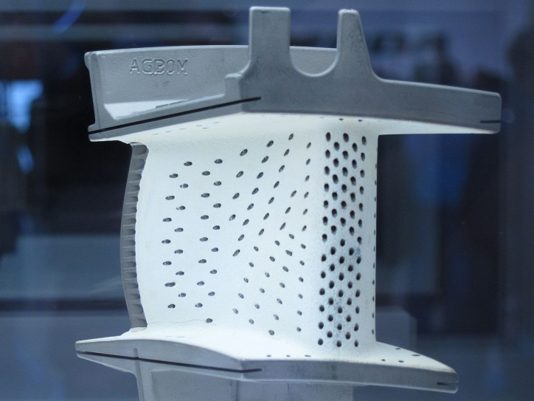
First developed for military aircraft engines in the 1970s [2], film cooling is the injection of a small amount of cool air (bled from the exit of the compressor, prior to the combustor) through discrete ports on the surface of a part to be cooled. An example of a film cooled turbine stator vane shown in Figure 2; film cooling is also employed on rotor blades, combustor liners, and turbine component endwalls. Early film cooling holes were simple cylindrical holes mechanically or laser-drilled in the parts; modern designs use shaped film cooling holes formed with EDM machining techniques. For a given coolant flow rate, the use of a shaped coolant hole can provide perhaps the greatest enhancement of film cooling performance through reduced separation of the coolant and via reduction of flow structures which could otherwise enhance heat transfer to the cooled surface [3]. Due to their relative newness and frequently proprietary nature, shaped holes have not been thoroughly characterized in terms of their performance. An example of such a shaped hole used for film cooling research, along with the relevant angles and geometry, is shown in Figure 3. The film cooling diameter (D) is the basic dimension that all specifications and results are based upon; the length of a film cooling hole (L/D), spacing within an array (pitch p/D), and spatial reporting of data (streamwise x/D, lateral z/D) are all scaled by the film diameter. The holes may be oriented axially (axis of the hole aligned with the freestream flow direction) or with an off-axis orientation (a “compound angle”, in film cooling parlance).
Olivier Clenyen - Wikipedia
Figure 2: Film-cooled nozzle vane, with laser-drilled cooling holes and thermal barrier coating applied.
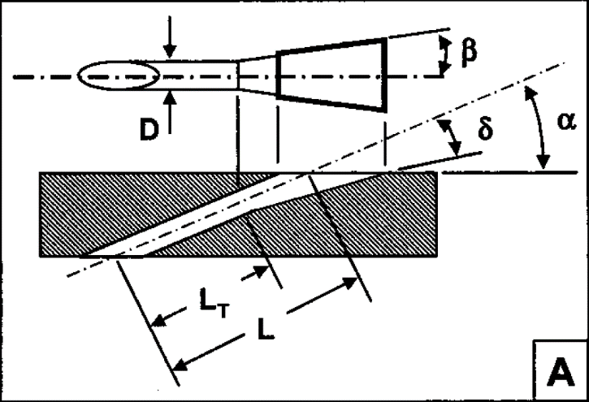
Upon injection, the momentum of the freestream combustion gas pushes the coolant into a thin film over the surface of the part, which acts as a locally protective layer of gas between the part surface and the freestream. The difference in temperature between the coolant and the overflowing freestream gas is usually quantified by the density ratio between the two flows, defined via equation 2:
Figure 3: Geometry of a laid-back fan shaped hole. Typically a lateral expansion angle (β) and forward expansion angle (δ) are used to expand the exit and increase film cooling performance. From [29]
$$DR=\frac{ρ_{c}}{ρ_{∞}}≈\frac{T_{∞}}{T_{c}}$$ | (2)
Using density ratio as a proxy for the temperature ratio follows from assuming the two flows are ideal gases, and that their pressures are the same. Some way of scaling the relative amount of coolant ejected is also needed, and a commonly used parameter is the blowing ratio (M) defined as:
$$M=\frac{ρ_{c}U_{c}}{ρ_{∞}U_{∞}}$$ | (3)
Blowing ratio is a ratio of the mass flux of coolant to that of the mainstream flow. M is perhaps the most commonly reported parameter in film cooling studies to characterize the coolant flow rate, and also quantifies the heat capacity of the coolant flow. An alternative to M is the momentum flux ratio (I), which is defined as:
$$I= \frac{ρ_{c}U_{c}^{2}}{ρ_{∞}U_{∞}^{2}}=\frac{M^{2}}{DR}$$ | (4)
This parameter captures the ratio of momentum flux between the coolant and mainstream gas, and consequently the ability of the mainstream to turn the coolant jet towards the wall. At low I, the coolant is held close to the surface, while at higher flow rates the momentum of the jet carries the coolant up and into the mainstream where it disperses without interacting with or cooling the wall.
A third parameter relating the coolant flow to mainstream flow rate is the velocity ratio (VR), which is defined in terms of coolant and mainstream velocity as follows:
$$VR=\frac{U_{c}}{U_{∞}}=\frac{M}{DR}$$ | (5)
Velocity ratio is used when matching velocity gradients is deemed important or when scaling coolant flow without considering the relative density of the coolant. Each of these scaling parameters has merits, and during planning of an experiment, the question becomes one of selecting the appropriate parameter to match, given that the DR in many experiments differs from that within an engine. Oftentimes engines operate at DR = 2.0 or higher, while many laboratory experiments are performed at DR = 1.0-1.2. From equations 3-5, it is clear that M, VR, and I cannot all be matched when DR varies between engines and labs. Exactly how the behavior of film cooling scales from low to high DR is not entirely understood, especially for shaped film cooling holes.
In film cooling research and engine design, the performance of the film cooling is typically quantified by the adiabatic film effectiveness$(η)$, defined as a non-dimensional temperature as in equation 6:
$$η= \frac{T_{∞}-T_{aw}}{T_{∞}-T_{C}}$$ | (6)
Frequently just referred to as “the effectiveness,” this is the temperature which film coolant would impose on the surface if there were no heat transfer to the wall. In this formulation, the mainstream and coolant flows have temperatures $T_{∞}$ and${ T}_{C}$, respectively, while the temperature of the wall is${ T}_{aw}$. At high speed conditions, $T_{∞}$ is usually taken to be the recovery temperature of the freestream flow, although the difference is small below Mach numbers of Ma∞ = 0.2 or so. The adiabatic effectiveness is used as a metric of film coolant performance because $T_{aw}$ represents the temperature of the air immediately above the surface of the turbine part, and is therefore the driving temperature for heat flux into the part [4].
Due to film cooling and any internal cooling used, the turbine vanes and blades are cold relative to the freestream combustion gases, so heat transfer q_{w} occurs into the part. The heat transfer coefficient $h_{f}$ can be defined according to equation 7 [5]:
$$q_{w}=h_{f}\left(T_{aw}-T_{w}\right)$$ | (7)
where T_{w} is the temperature of the wall. In the case where there is no film cooling present, the heat transfer coefficient becomes defined by equation 8:
$$q_{w}=h_{0}\left(T_{∞}-T_{w}\right)$$ | (8)
Adiabatic effectiveness varies widely, with $η$ = 1.0 indicating the best-possible performance and $η$ = 0 indicating no film cooling benefit at all. Effectiveness is strongly dependent on the coolant flow rate and film cooling hole geometry. Film cooling also causes some local change in the heat transfer coefficient, typically quantified by the ratio of heat transfer coefficients $h_{f}/h_{0}$, which is known as the heat transfer coefficient (HTC) augmentation. Generally, laterally-averaged values tend to range between $\overline{h_{f}/h_{0}}$ = 1.0-1.5, with lesser dependence on film cooling flow rate and geometry than adiabatic effectiveness normally exhibits. In practice, designers use $η$ and $h_{f}$ as boundary conditions for finite-element analysis codes which then predict the temperature distributions within the actual metal parts, with a goal to avoid hot spots and part degradation.
It is possible to build models from conductive materials and directly measure the temperature distributions in the part. In this case, the “overall” film effectiveness $(ϕ)$ is measured, which is defined in equation 9:
$$ϕ= \frac{T_{∞}-T_{w}}{T_{∞}-T_{C}}$$ | (9)
Use of this method requires matching the Biot number of the model material, as well as appropriately simulating the heat transfer coefficient distributions present inside and outside the part. Such methods have been developed and demonstrated by our research group, but their adoption by the industry does not currently seem widespread. The focus of this work, therefore, is advancements in adiabatic effectiveness and heat transfer coefficient measurements.
A few comments on the state of HTC augmentation measurements are in order at this point. Compared to measurements of $η$, which are relatively straightforward to perform, HTC augmentation studies can entail considerable difficulty and uncertainty. There are also a number of published studies showing $\overline{h_{f}/h_{0}}$ ≈ 1.0, mostly for axially-oriented holes with a quiescent plenum coolant feed. Thus greater emphasis is usually placed upon $η$ measurements to inform cooling designs, while HTC augmentation studies have become less common. However, newer film cooling designs, which include crossflow-fed cooling holes and compound angle holes, present a departure from the flow physics present in many published HTC augmentation studies, and thus a need for additional investigation. An accurate understanding of the heat transfer coefficient is needed to determine whether or not a film cooling design is actually detrimental in some conditions, as areas with low $η$ but high $h_{f}/h_{0}$ could see an increase in heat loading. Secondly, accurate spatially resolved values of $h_{f}$ are needed to correct $η$ measurements for radiation and conduction effects, as will be discussed in the following sections. Spatially resolved $h_{f}/h_{0}$ data are hard to find in the literature, but local values of $h_{f}/h_{0}$ > 1.6 have been observed [6] [7] [8].
Finally, there is inconsistency in current state-of-the-art measurements of HTC augmentation, specifically for shaped film cooling holes. Studies performed by Saumweber et al. [9] at the University of Karlsruhe in Germany show very high values of h_{f}/h₀ > 1.5 over the measurement range (x = 0 – 20D from the cooling hole). Meanwhile, a study by Liu et al. [10] used substantially similar film cooling geometry, yet recorded much lower (by ~30%) HTC augmentation, with h_{f}/h₀ ≈ 1.0 for the same conditions and measurement range. It should be noted that neither investigation directly measured the heat transfer coefficient; a superposition analysis was used in the case of [9] while [10] utilized a 1D transient heat transfer analysis. Boyd [6] performed direct measurements of HTC augmentation for shaped holes, and found results which were between those of [9] and [10]. Additional measurements will be useful in understanding precisely what the true behavior of HTC augmentation is.

Data Presentation and Measurement Methods
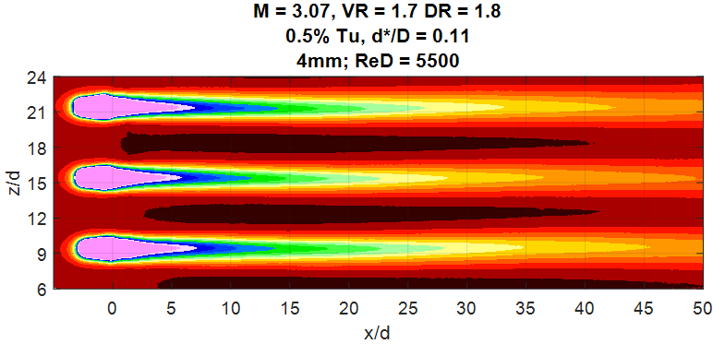
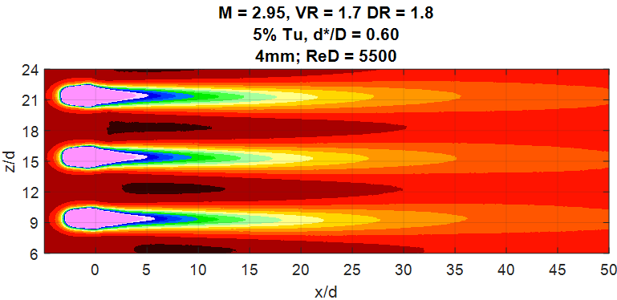
Adiabatic Effectiveness: Adiabatic effectiveness can be measured by constructing film cooling models or model engine geometry from a low-conductivity material such as machinable polyurethane (k = 0.045 W/m²K) or polystyrene foams (k = 0.025 W/m²K). The film cooling configuration of interest is machined directly into this foam. Our lab uses one or more high-resolution infrared cameras to measure a map of the surface temperature $(T_{w})$. With these measurements and appropriate conduction corrections to convert ${ T}_{w}$ into ${ T}_{aw},$ it is possible to calculate η via equation 6 above, and the spatial distribution of effectiveness for two different conditions is shown in Figure 4. For faster comparisons, the data is frequently averaged laterally in the z/D direction, producing a metric appropriately termed the laterally-averaged adiabatic effectiveness $\overline{η}$. This is without a doubt the most widely-compared and cited metric of film cooling performance seen in the literature. An example for the two cases below is given in Figure 5. Note that significant spatial variation in the contours of Figure 4 exists. Much of this is lost in the averaging for Figure 5, and in fact the results would appear to be within experimental uncertainty of each other, which is not correct.
Figure 4: Representative contours of adiabatic effectiveness for plenum-fed shaped holes.
$$η$$
Heat Transfer Coefficient Measurements: There are several methods for measuring the heat transfer coefficient in film cooling problems, an excellent review of which is given by Emily Boyd [6]. The centerpiece of her doctoral work was the development of a new direct method of heat transfer coefficient measurement for high-DR experiments. Prior to this, there were very few studies which considered $h_{f}/h_{0}$ at other than DR = 1.0. The new method she developed requires a total of three tests to acquire${ h}_{f}/h_{0}$:
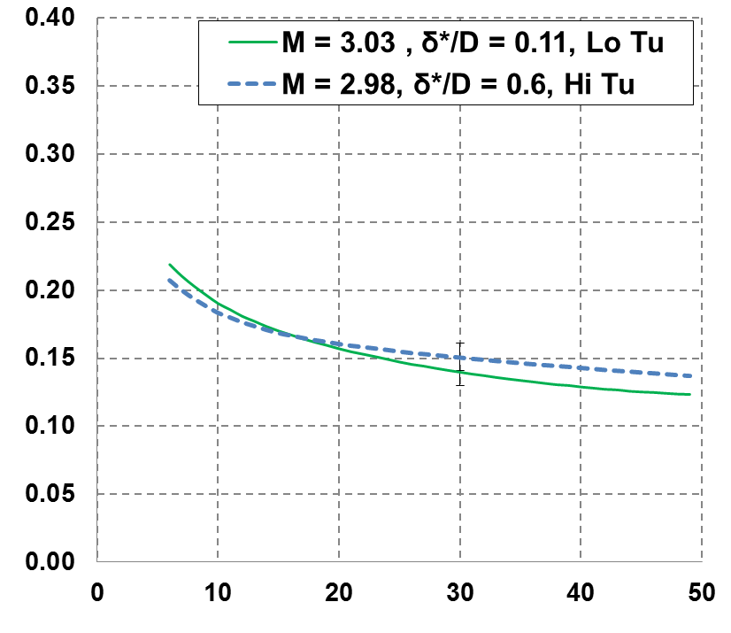
- Measurement of the wall temperature T_{w} with film cooling and constant heat flux from the wall: The experimental setup and approach flow is the same as for adiabatic effectiveness measurements described above. A thin stainless steel foil is placed on the surface of the foam substrate, downstream of the film cooling holes. It is important that the foil used is as thin as possible to minimize stray lateral conduction; thicknesses of t = 0.0005” – 0.001” are usually preferred. A known electric current is then passed through the foil, generating a constant heat flux q_{w} out of the surface (subject to corrections for conduction and radiation). This heat flux is related to the heat transfer coefficient via equation 7 (subscript numbers in equations refer to the test in which a variable is measured):
Laterally-averaged Adiabatic Effectiveness $\left(\overline{η}\right)$
Downstream distance (x/D)
Figure 5: Laterally-averaged adiabatic effectiveness for the two cases shown above in Figure 4. Note that significant spatial variations are obscured when averaged data is presented.
$$h_{f}=\frac{q_{w}}{\left(T_{aw,2}-T_{w,1}\right)}$$ | (7)

- Measurement of the adiabatic wall temperature T_{aw,2}: The value of T_{aw} is needed to deduce h_{f}, and this is provided from an adiabatic effectiveness experiment (equation 10 is equation 6 re-cast):
$$T_{aw} = T_{∞}-η{(T}_{∞}-T_{C})$$ | (10a)
Once $η_{2}$ has been measured, the temperatures of the coolant or freestream are updated to the values present during Test 1, in order to account for any changes that occur between Tests 1 and 2:
$$T_{aw,2} = T_{∞,1}-η_{2}{(T}_{∞,1}-T_{C,1})$$ | (10b)
Now, the heat transfer coefficient with film cooling is calculated via equation 11:
$$h_{f}=\frac{q_{w}}{\left(T_{∞,1}-η_{2}{(T}_{∞,1}-T_{C,1})-T_{w,1}\right)}$$ | (11)
- Measurement of no-film heat transfer coefficient, h₀: Since h_{f} can be affected by the injection of film coolant, the ratio of the heat transfer coefficient with and without film cooling, h_{f}/h₀, is usually presented. Thus, the value of h₀ is needed. Experimentalists vary in their approach to this problem, and many just use a flat plate correlation, although it is possible to measure it by deactivating the film cooling jets and covering over the holes in a third measurement:
$$h_{0}=\frac{q_{w}}{\left(T_{∞,3}-T_{w,3}\right)}$$ | (8)
At this point, h_{f} and h₀ are acquired, and h_{f}/h₀ is trivially calculated. The value of h_{f}/h₀ can be presented in spatially-resolved contours or averaged laterally, like effectiveness. It is also important to consider the nature of the approaching thermal and hydrodynamic boundary layer. Actual turbine hardware usually has a thermal boundary layer upstream of the film cooling holes, which can be displaced by the injection of film cooling, producing greater h_{f} downstream of the injection point. If only a downstream heating plate is used, this effect is not measured. Therefore, a heat flux plate is needed upstream of the film cooling holes, such that the thermal boundary layer is appropriately developed as would be in an actual engine. Such upstream heating conditions are rarely seen in the open literature, but an excellent example is seen in Harrison et al. [8], where results for several hydrodynamic and thermal approach boundary layer conditions were presented. This study showed profound effects due to an upstream heating condition, especially for cases with a thin approach boundary layer.
Thermal Field Measurements: The thermal field is measured with a very fine thermocouple that is moved through a pattern with a computerized 3-axis traverse. The finest thermocouple I have been able to reliably construct is d = 0.001” (0.025mm) in diameter. Typically, results are presented as a non-dimensional value θ:
$$θ=\frac{T_{∞}-T_{probe}}{T_{∞}-T_{c}}$$ | (12)
The thermocouple junction is supported by a small-diameter probe holder (d = 0.5 mm, 0.020 inches) which minimizes interference with the freestream flow. The traverse has a minimum resolution of 0.5 microns.
Velocity Field and Boundary Layer Measurements: Several methods are available to measure velocity fields, including hotwire anemometery, PIV, and LDV. The PIV system currently only supports measurements along the streamline of the flow since it utilizes a single camera.

Test Facility
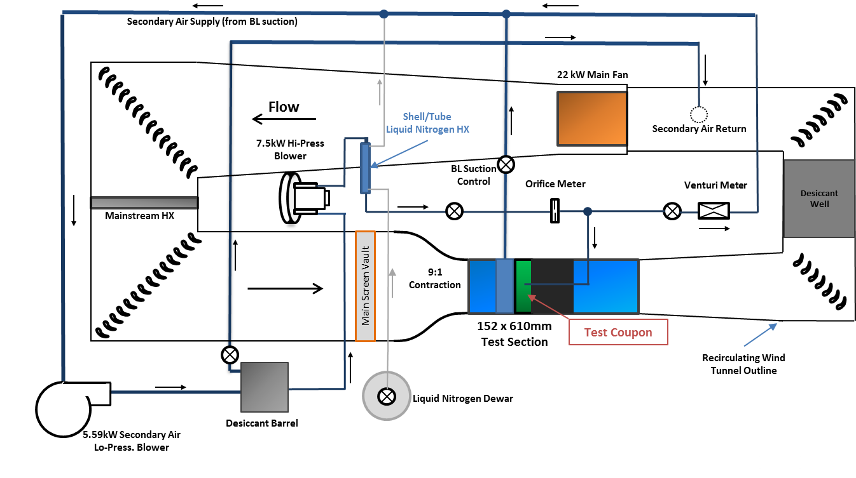
The work performed thus far and all that remains will be done on the low-speed 6” x 24” recirculating wind tunnel within the Turbulence and Turbine Cooling Research Laboratory at UT-Austin. A schematic of the wind tunnel and auxiliary systems is shown in Figure 6. A flat plate wind tunnel is advantageous as it exposes the fundamental physics of the film cooling problem. Significant upgrades and overhaul of the facility were completed over the past year to support this investigation and others. The mainstream fan has been upgraded from a 5HP to a 30HP unit to increase the flow rate through the test section and provide velocities up to U∞ = 70 m/s. A chilled water cooling system was also designed and installed in order to control mainstream temperature within the wind tunnel and remove the increased heat produced by the larger fan. With the chilled water system, it is possible to maintain temperatures between T∞ = 285-320K to an accuracy of T∞ ± 1K. Two new shell-and-tube coolant heat exchangers and all-new coolant piping and instrumentation was installed in order to provide more precise control of coolant temperature and flow rates. All of the test section components, including the walls, adjustable ceiling, and fixed floor elements, were replaced due to wear of the original components.
Figure 6: Diagram of the TTCRL flat plate wind tunnel facility.
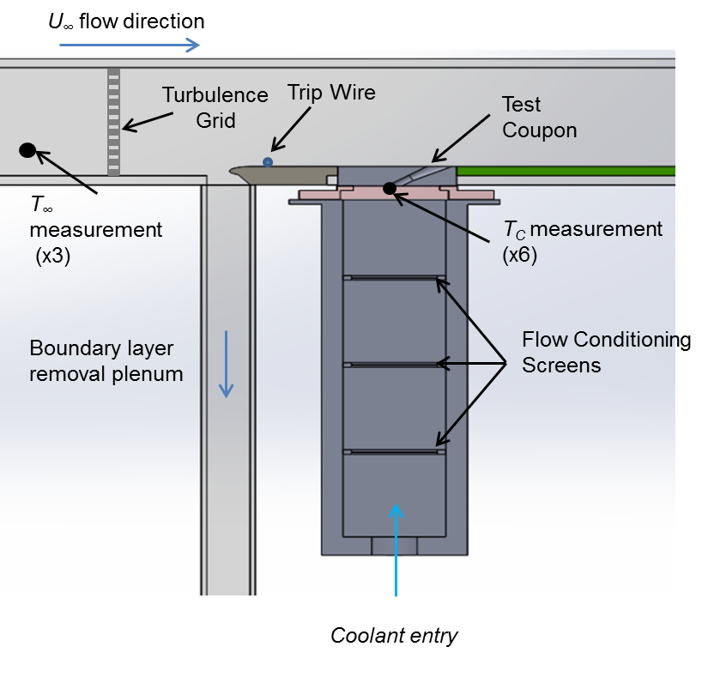
A diagram of the test section and plenum assembly is shown in Figure 7. The mainstream flow approaches from the left, which is immediately downstream of a 9:1 contraction nozzle. A turbulence grid can be moved to three selectable positions or removed entirely, allowing a range of turbulence intensities and length scales to be produced. Without the grid in place, the tunnel has background turbulence intensity of approximately Tu = 0.5%. The boundary layer removal plenum is used to eliminate any approaching boundary layer, such that a new boundary layer forms just upstream of the test coupon and δ₉₉ is precisely known at the cooling hole breakout. The thickness of that boundary layer is then adjustable by using different trip wire positions or diameters. A laminar boundary layer is obtainable at low-turbulence conditions. Velocity in the wind tunnel is measured with two pitot static probes located on the upstream and downstream sides of the leading edge, and temperature (T∞) is measured with three welded-junction Type E thermocouples distributed across the span of the test section.
Figure 7: Detail of the test section and coolant plenum assembly.
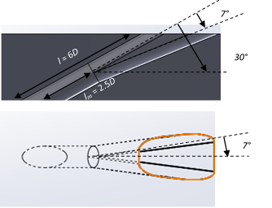
Two shaped film cooling hole designs will be utilized in this work, both based on geometry first proposed by Schroeder and Thole [11], wherein it was known as the “7-7-7 shaped hole.” A detail of this geometry is shown in Figure 8. An axially-oriented hole is shown, but a compound angle with γ = 45° will also be tested. These film cooling holes are six diameters in length and are injected into the freestream at α = 30°. The lateral expansion angles are β = 7° with the forward expansion angle of δ = 7°. The metering hole length is l_{m}/d = 2.5, and the holes have an area ratio of AR = 2.5. A single row of film cooling holes is machined into a coupon, which is made from a low-conductivity polyurethane foam. Depending on the diameter of the holes, between 8 and 20 holes are machined into the coupon. As defined in [11], the holes are spaced with a pitch of p = 6D diameters apart. The shaped holes are fed from a plenum, which is constructed so that the velocity in the plenum is approximately 1% of the velocity through the coolant holes. This has the effect of isolating internal coolant feed effects from the external freestream effects under investigation in this work. At least two different cooling hole diameters will be considered, D = 4mm and 9mm, which allows decoupling of the freestream Reynolds number Re_{D} and Mach number Ma∞, as well as different relative boundary layer thicknesses δ*/D.
Figure 8: Geometry of the 7-7-7 holes used for this work.
Coolant is obtained by extracting and cooling a portion of the mainstream air in single-pass shell-and-tube heat exchangers, where liquid nitrogen is introduced on the shell-side, counterflowing the air in the tubes. The exit air temperature is controlled by changing the nitrogen flow rate. The coolant is metered through sharp-edged orifice plates installed to ASME standards, enabling the use of an ISO 5167 correlation for the discharge coefficient. Two heat exchangers and orifice plates are available and are of different sizes to allow flexibility and accurate measurement when the freestream velocity is varied or the number of cooling holes is changed. The flow rate through the heat exchanger is kept nearly constant to maintain stability in the system, so to control the amount of film cooling injection, only a portion is admitted to the plenum; the rest of the coolant (25-50%) is metered back into the wind tunnel through a venturi meter. The coolant temperature (T_{c}) is measured at the entrance to the film cooling holes with 4-6 Type E thermocouples.

Description of an Experiment
A single “experiment” usually requires 6-8 hours to perform, including ~16 hours of preparation over preceding days. Preparation includes installing the test geometry and ensuring that all components are correctly positioned. The wind tunnel is then carefully sealed to prevent frost form forming in the cooling geometry. After ~100 lbs. of desiccant is loaded into the tunnel, the system is started and allowed to cool to steady state for about two hours. Four to six hours of data collection is usually possible before the desiccant is exhausted and must be regenerated. If no changes are made, the experiment can be continued the following day without significant preparatory work. It is usually possible to measure 15-20 discrete test conditions per day, including but not limited to varying T_{u}, M, DR, Re_{D}, and T∞.
To characterize a freestream effect or a film cooling hole design, a range of coolant flow rates are tested, with a representative blowing ratio range of M = 0.5 – 3.0. This scaling is sometimes done by velocity ratio instead of M. Typically, five images are captured with the IR camera at the same time as temperature and pressure measurements (sampled with a National Instruments Data Acquisition system) from the wind tunnel facility. The images are taken over a period of 5-10 minutes to validate the steady-state nature of the tunnel. A variety of in-house Matlab scripts then spatially correct and reconcile the IR camera images with the thermal and flow data.

Objective 1: Scaling of Density Ratio Effects

Motivation
Due to the conditions present in gas turbine engines, the density ratio in an engine is typically around DR ≈ 2.0. Historically, many film cooling experiments were frequently performed at lower values, around DR = 1.0 – 1.2. High-DR tests require either a very large temperature difference between the mainstream and coolant, or the coolant must be a foreign gas with higher molecular weight such as carbon dioxide, argon, or sulfur hexafluoride. Either approach brings potential problems. Low coolant temperatures can introduce errors due to conduction and radiation, and can cause experimental issues with frost or deformation in shape due to thermal expansion/contraction. Foreign gas coolants require a separate coolant supply of some sort and entail possible errors due to different fluid properties, not to mention environmental or occupational hazards. Regardless, the recent trend in the film cooling community has been towards higher DR studies, and our lab has solved many of the issues which typically plague low-temperature experiments, enabling operation up to DR = 2.0. However, recent work by Anderson [12] and Watson [13] has shown there can be significant differences in film cooling effectiveness when the density ratio is changed, and Boyd showed significant effects on the heat transfer coefficient at varying density ratios [6]. This is of interest to the film cooling community because there is a large amount of low-DR data available, and understanding how to scale this data to engine-like conditions is important.
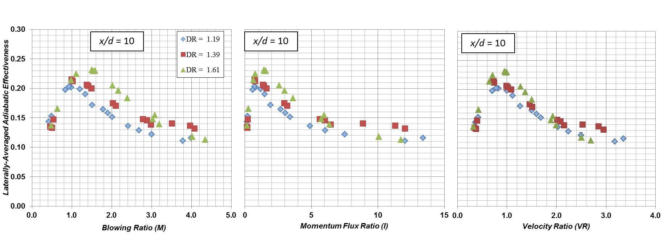
Anderson [12] showed these density ratio effects can be partially mitigated by selecting an appropriate coolant flow rate parameter, as shown in Figure 9 below. The film effectiveness is plotted as a function of blowing ratio (M), momentum flux ratio (I) and velocity ratio (VR) for three different density ratios, DR = 1.2, 1.4, and 1.6. The peak effectiveness occurred at different blowing ratios, where an increase of DR shifted the best-performing blowing ratio higher. Scaling via I improved the comparison somewhat, but VR provided the best scaling of these three. Note however that there was still an offset in maximum performance, with the peak of the DR = 1.2 data approximately η = 0.04 lower than the DR = 1.6 case.
Figure 9: Comparison of different scaling parameters M (left), I (center) and VR (right), clearly showing a superior collapse of the data with VR. Results typical of additional downstream locations. Data from [12].

Expected Contributions and Methods
The two proposed contributions for this work are 1) measurements of DR effects for a new film cooling configuration of compound-angled shaped holes (CA/SH), and 2) a correction method to scale the effectiveness from a low DR to an equivalent flow rate at high DR. This will be accomplished the following ways:
- It was theorized in [12] that the amount of velocity shear is responsible for the rate of mixing between the coolant and freestream, which explains why VR was the best scaling parameter. Measurements with CA/SH holes, which have significantly greater velocity shear than axial holes, will help to bear this out. Measurements of η and h_{f}/h₀, and some thermal field measurements, will be performed. Thermal fields will be made only at a selection of coolant flow rates.
- Measurements of η at two additional density ratios, DR = 0.95 and 2.0, will extend the data throughout the range of most experiments in the literature. This will form a database from which to extract a correlation for effectiveness as a function of coolant flow rate. Consistent with the already completed work, this experiment will be performed with axial shaped holes over a range of coolant flow rates. To complete the adiabatic effectiveness tests, one additional experiment is needed at DR = 2.0.
It is important that the any errors in effectiveness caused by lateral conduction and radiation be understood and corrected, since a very wide range of temperatures is utilized in this work.

Work Completed
Measurements at DR = 0.95 for axial shaped holes have been completed. However, the data has not been processed or compared with the previous results. Additionally, effectiveness and HTC augmentation have been measured at DR = 1.20 for the CA/SH holes.

Remaining Experiments
The experiments remaining to be carried out are listed below in Table 1:
Table 1: Measurements completed and remaining for the density ratio effects study.
DR | 0.95 | 1.20 | 1.40 | 1.60 | 2.00
Effectiveness | Finished, not published | Finished | Finished | Finished | Remaining
Thermal Field | Remaining | - | Remaining | - | Remaining
CA/SH η | Remaining | Finished | - | Remaining | Remaining
CA/SH h_{f}/h₀ | Remaining | Finished | - | Remaining | -

Objective 2: Investigate Approach Flow Effects on Film Cooling Effectiveness and Heat Transfer

Motivation
Film cooling experiments are typically performed in laboratories at conditions close to atmospheric pressure and ambient temperature, rather than engine conditions. As such, a constellation of non-dimensional groups may need to be matched to achieve physical similarity to engine conditions. Film-cooling parameters such as M and DR are important to match, but it is also important to characterize the freestream approach flow. Perhaps the most obvious approach flow parameters are: 1) the boundary layer thickness at the film injection location; 2) the Mach number of the overflowing gas; 3) Reynolds number, characterized by the size of the film cooling jet; and 4) turbulence intensity and length scale. A partial list of such parameters is given in Table 2. There are few studies which vary individual parameters in isolation from each other. Understanding how these parameters influence film cooling is critical for engine designers, since it is extremely difficult to precisely match all non-dimensional groups between engine and laboratory conditions. Designers need to know which parameters they must insist on matching, and which ones can be allowed to vary.
Test Parameters |  | Engine | This Study
Freestream Temp, T∞ |  | >1500K | 310K (37°C)
Freestream Mach No. Ma∞ |  | 0.1-0.8 | 0.02-0.15
Coolant Density Ratio, DR |  | 1.8-2.0 | 1.8
Coolant Blowing Ratios, M |  |  | 1.0, 2.0, 3.0
Freestream Turbulence Intensity, T_{u} |  | 5-20% | 0.5%, 5%, 10%
Turbulence Length Scal,e Λ_{x} |  | 5-7mm | 10-20 mm
Cooling Hole Diameters, D |  | ~0.5 mm | 1.8, 4, 9 mm
Reynolds No. Re_{D} |  | 0.5-4x10⁴ | 0.5-1.5x10⁴
Plenum-Coolant Velocity Ratio |  |  | <1%

Table 2: Parameters of interest to preserve similarity to engine conditions

Influence of freestream Mach number: A wide range of Mach numbers can exist in engines. The flow through the combustor is subsonic and typically at speeds of Ma∞ < 0.2. The engine geometry contracts near the turbine inlet, and the flow enters the first stage of stator vanes around Ma∞ = 0.15 – 0.20. The vanes accelerate the flow to supersonic speeds, which then decelerates as it passes through the rotor at relative velocities of Ma∞ = 0.2 – 0.8. Film cooling jets could possibly encounter any of these Mach conditions. Some investigation of Ma∞ effects has been done, the earliest of which was by Liess [14]. His study considered Mach numbers of Ma∞ = 0.3-0.9 over an array of inclined cylindrical holes mounted in a flat plate, which were provided with a heated “coolant” flow, such that the density ratio was DR = 0.85. The experimental apparatus was only capable of measuring laterally-averaged effectiveness, and no measurable effect of Ma∞ was found. More recently, Saumweber and Schulz [15] extended the investigation to laterally-expanded shaped holes, and considered Mach numbers of Ma∞ = 0.15 – 0.45. Increasing Ma∞ corresponded to only slight increases in laterally-averaged effectiveness. It should be noted that in this experiment, Ma∞ was not isolated as a parameter of interest, and the Reynolds number and boundary layer thickness varied somewhat as well.
Many experimental investigations of film cooling occur at lower Mach numbers of Ma∞ = 0.0 – 0.2 or so, as high speed film cooling rigs are more difficult and expensive to operate. The effects of Ma∞ in this range are unreported in the open literature.
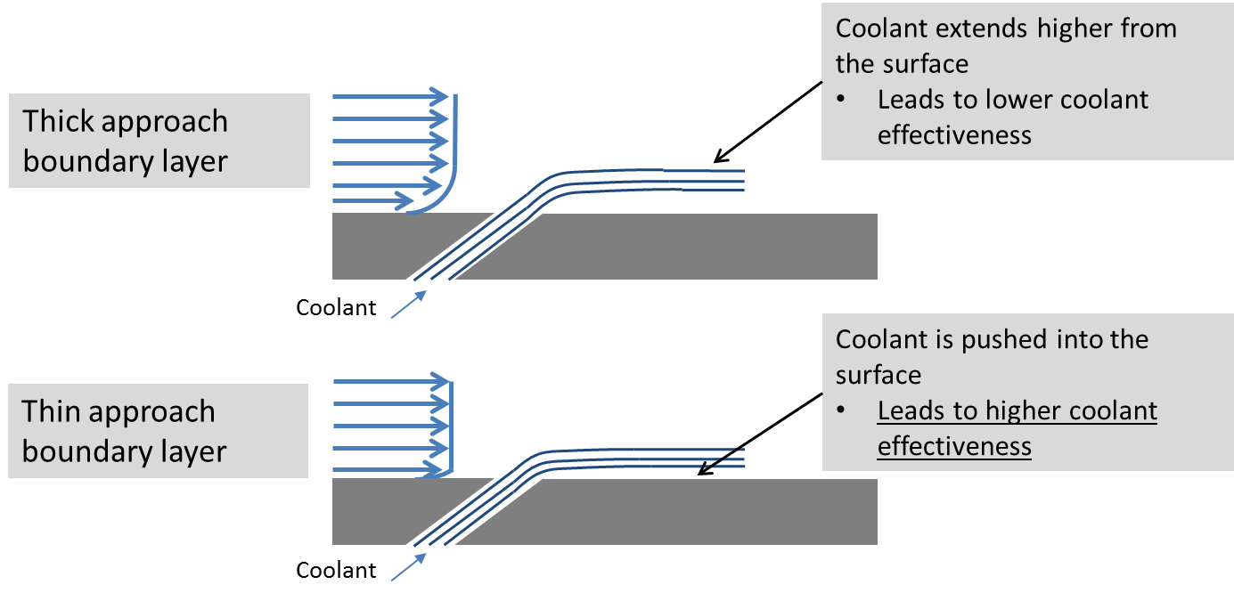
Influence of the Approach Boundary Layer. By convention, boundary layer thickness is oftentimes reported as the displacement thickness vs. hole diameter (δ*/D). In a first-order description, film effectiveness decreases with increasing δ*/D, as illustrated in Figure 10. If a thin boundary layer is present, the momentum of the high-speed approach flow pushes the coolant jet into the wall, which increases effectiveness. A thick boundary layer allows the jet to propagate farther away from the wall by its momentum, which decreases effectiveness. This was first described by Liess [14], who considered a range of boundary layers with displacement thicknesses of δ*/D = 0.1 – 0.6. For δ*/D < 0.2 there was no effect on performance, but above this value the laterally-averaged effectiveness dropped by 40% from $\overline{η}$ = 0.25 to $\overline{η}$ = 0.15. In other studies supervised by R. Goldstein at the University of Minnesota [16] [17], the effects of injection into a laminar boundary layer were considered, using round holes and a foreign gas for coolant; effectiveness and coolant jet profiles were measured via the concentration of the injected gas. It should be noted that they effected the change in boundary layer thickness by increasing the mainstream velocity, potentially introducing confounding changes in other flow parameters. For one injection rate of M = 0.5, DR = 0.86, decreasing the displacement thickness from δ*/D = 0.235 to δ*/D = 0.173 increased the height of the concentration profile by ~20%, while increasing the spanwise spreading as well. For reference, a previous investigation from our lab [18] found variations of δ₉₉/D = 0.5-2.0 around a turbine vane.
Figure 10: Diagram of film coolant interaction for a thick (top) vs. thin boundary layer (bottom).
Influence of Reynolds Number. The Reynolds number can be defined by a variety of length scales and gas properties, and a definition which best captures the interaction of the injected coolant with the overflowing freestream gas should be utilized. Selecting the freestream properties and velocity with the cooling hole diameter (D), produces a parameter that, in combination with blowing ratio (M), thoroughly characterizes this interaction:
$$Re_{D}=\frac{ρ_{∞}U_{∞}D}{μ_{∞}}$$ | (13)
Increasing this Reynolds number generally implies higher turbulence generation between the freestream and the coolant, and thus greater mixing of the freestream into the coolant jet. This could promote greater lateral spreading of the coolant, resulting in increased effectiveness, but also dilution of the coolant with hot gas, a competing effect. Experimental results on the influence of Re_{D} number on film cooling performance are very scarce in the open literature. Boyd [6] varied Reynolds number from Re_{D} = 2,700 to 5,500 in a study which used shaped holes, and found that effectiveness was increased by as much as η = 0.05, an increase of about 20%, when Re_{D} was increased. The increase was mostly attributed to differences in boundary layer thickness, which was not matched. At present, no studies that isolated Re_{D} effects from those of Ma∞ or δ*/D are available in the literature.
Influence of Turbulence Intensity and Length Scale. The flow within a turbine combustor is very turbulent, where turbulence induced by combustor swirlers and dilution jets in the combustor walls improves combustion. The turbulence intensity (Tu) entering the nozzle guide vanes can approach Tu = 15-20% [15] [19]. The effects of turbulence on film cooling effectiveness have been rather extensively researched for cylindrical cooling holes, with most focus on freestream turbulence intensity and less investigation of length scale (Λ_{x}) effects.
For round holes, high Tu enhances mixing of the coolant with the freestream, which will quickly disperse a low-M film cooling jet. At higher M, the jet will separate from the surface, so the enhanced mixing will disperse the jet back into the wall, increasing effectiveness. This was observed by Saumweber & Schulz [15], Kadotani & Goldstein [20], Ames [21], and several others. Meanwhile, there are relatively few results for shaped holes. The same study by [15], and an earlier study performed in 2003 by the same authors [9], indicates a reduction in overall effectiveness due to high Tu regardless of M, likely due to the use of very closely spaced film cooling holes (p = 3D). Closely spaced holes produce a closed film on the surface, which turbulence will disperse into the freestream; discrete jets from widely-spaced holes are prone to increased lateral spreading as described for cylindrical holes. Schroeder & Thole [22] have presented results for widely spaced holes (p = 6D), which were more in line with those of round holes.
Turbulence integral length scale Λ_{x} is also used to characterize flows relevant to film cooling. A large length scale implies larger eddies and structures within the turbulent flow; this should result in buffeting and bulk motion of the coolant jet. Conversely, small length scale effects will tend to disperse the jet. Film cooling holes in engines are around D = ~0.5mm in diameter, while the dilution jets, which seem to drive the integral length scale in a combustor, are 10-20D larger [4]. Measurements have confirmed values of Λ_{x} = 5-7mm at the exit of a combustor [23], which for a representative cooling hole diameter of D ≈ 0.5mm, would result in Λ_{x} = 10D – 14D. Studies of Λ_{x} on film cooling mostly consider smaller values. When increased from Λ_{x} = 0.06D – 0.33D, some effect on round holes was observed [20], but little to no change in effectiveness for round or shaped holes was seen for Λ_{x} = 1.0D – 2.0D [15]. A recent study by Kingery & Ames [24] considered full-coverage shaped holes on a leading edge model, with Λ_{x} ≈ 8D. They claimed that increasing the length scale was shown to increase film cooling dissipation, although it is unclear to this author how they arrived at their conclusion.

Expected Contributions and Methods
A series of experiments will be performed to look at how adiabatic effectiveness and heat transfer coefficient augmentation respond to changes in non-dimensional approach flow groups. The following parameters will be investigated:
- Boundary layer thickness: The boundary layer thickness can vary widely with engine geometry and positioning of coolant holes around a turbine vane or blade, and its influence on shaped holes is unreported. A range of boundary layer thicknesses and character will be imposed upstream of the film cooling holes. With different hole diameters and trip sizes and locations, a range of boundary layer thicknesses of δ*/D = 0.1 – 0.6 is attainable (δ₉₉/D = 1.0 – 5.5). Adiabatic effectiveness, heat transfer coefficient augmentation, and thermal fields will be used to characterize these effects.
- Mach number: This study will consider Ma∞ = 0.03 – 0.15, while other parameters are held constant (Reynolds number and boundary layer thickness). Adiabatic effectiveness experiments will be used to characterize these effects.
- Reynolds number: The Reynolds number will be varied between Re_{D} = 5,000-15,000, with other freestream parameters held constant. This will be accomplished by using cooling holes of several diameters. Adiabatic effectiveness and thermal fields will be utilized to characterize these effects.
- Turbulence intensity and length scale: Turbulence intensity and length scale will be varied by utilizing different diameter turbulence grids, and different placement in the wind tunnel. Turbulence intensities of Tu = 0.5% - 10% are proposed, with length scales of Λ_{x} = 1.0D – 15D possible, to appropriately simulate engine-like turbulence. Adiabatic effectiveness and heat transfer coefficient augmentation measurements will be utilized to characterize turbulence effects.

Work Completed
Effects of freestream approach parameters on adiabatic film cooling effectiveness: The investigation into boundary layer thickness, Reynolds number, and Mach number effects has begun. The investigation yielded promising results and has provided direction for upcoming work.
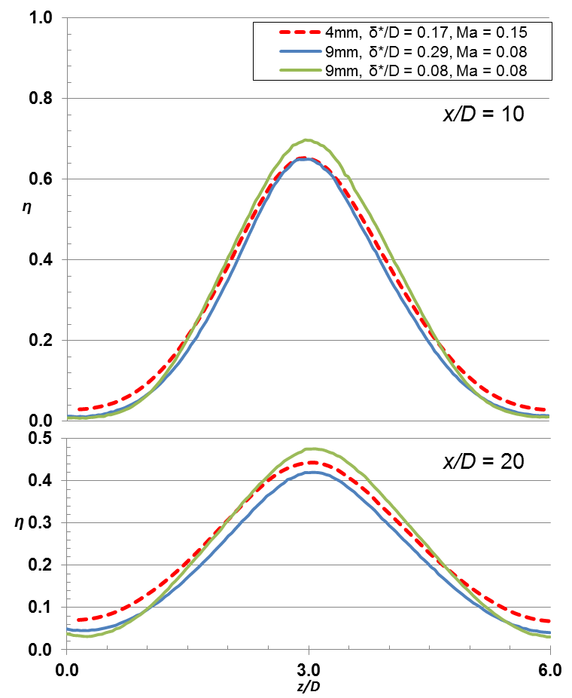
Little effect on freestream Mach number (Ma∞) was found over a range of Ma∞ = 0.08 – 0.15. The comparison is shown in the lateral $η$ distributions in Figure 11, which is a lateral slice across the measurement region. While the boundary layer thickness was not matched for all three cases shown, the high Ma∞ case shown in the dotted red line brackets the two low Ma∞ cases shown in green and blue, indicating little effect from Ma∞. This is not surprising, since these measurements occur in a range where compressibility effects are negligible. These results do allow us to accept small variations in Ma∞ while attempting to preserve other parameters.
Figure 11: Effects of Mach number on lateral adiabatic effectiveness distribution of coolant.
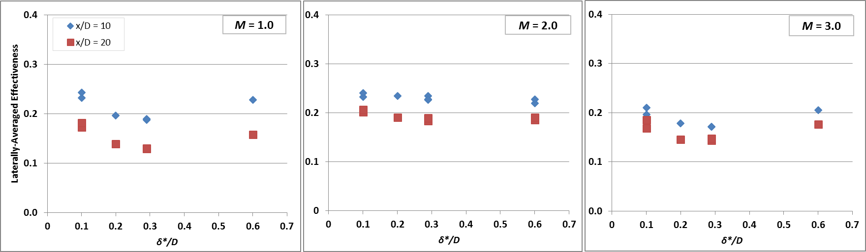
The effects of boundary layer thickness on adiabatic effectiveness have been investigated as well over a range of values, turbulence conditions, and coolant flow rates. The results thus far have shown some interesting effects. Figure 12 gives $\overline{η}$ values at different downstream locations for a range of blowing ratios and δ/D values. Note that boundary layer thickness has a larger effect on $\overline{η}$ when M = 1.0 and 3.0 than at M = 2.0. This is a significant result, which likely occurs due to the effects of turbulent mixing within the boundary layer.
Figure 12: Effect of boundary layer thickness on $\overline{η}$ at different x/D locations and M values. Note that the lowest and highest M (left and right, respectively) are most affected by changes in δ.
The effect of Reynolds number on $η$ is shown in Figure 13 for two cases, Re_{D} = 5,400 and 15,000. Based on the results described above, the boundary layer thickness was held constant but Ma∞ was allowed to vary somewhat. These are significantly different results, which was somewhat surprising. The effectiveness at Re_{D} = 15,000 was much higher along the centerline of the film cooling jet, while the width of the jets was similar. This indicates the jet was colder above the wall, and therefore less mixing with the freestream occurred relative to the Re_{D} = 5,400 condition.
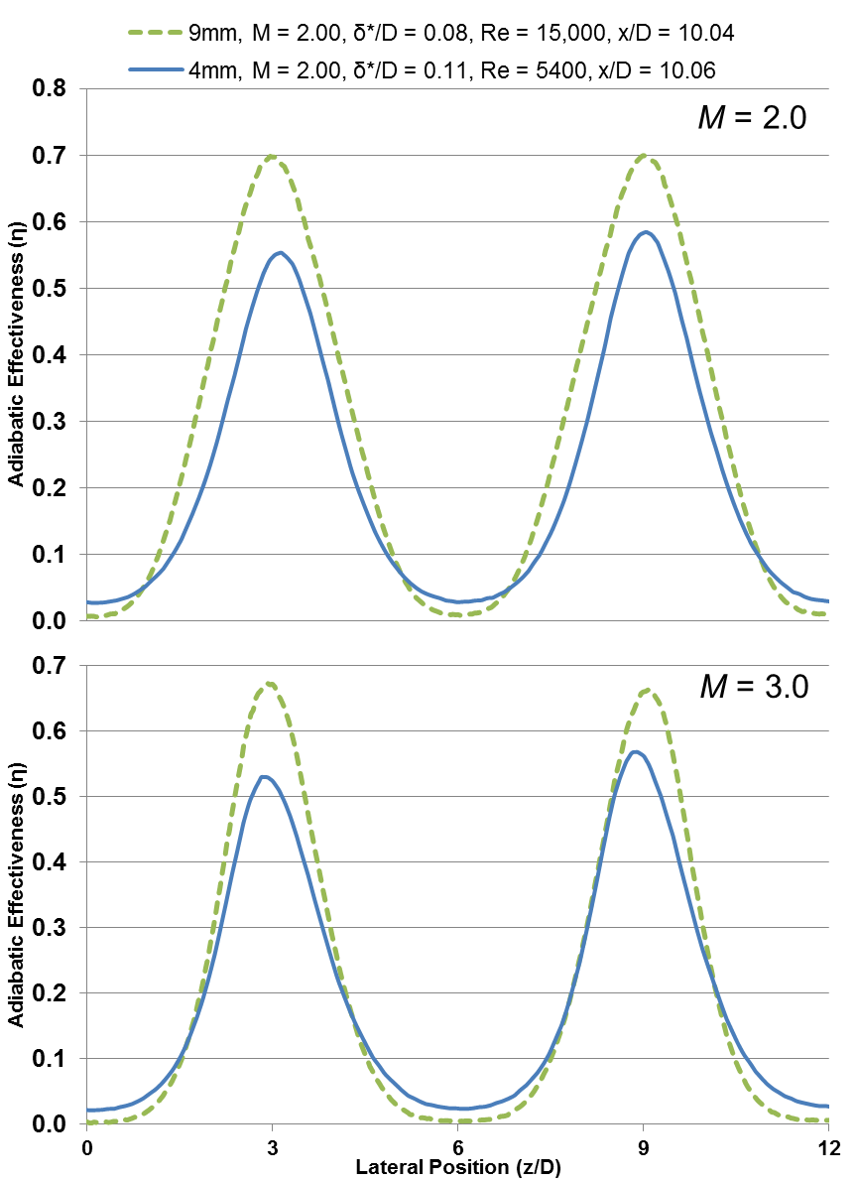

Figure 13: Effect of Re_{D} on lateral distributions of adiabatic effectiveness. Higher Re_{D} results in higher effectiveness for both M.

Remaining Experiments
Table 3 below gives a summary of the experiments remaining for the different freestream effects. A substantial amount of measurements remain to be completed, although many can be completed in a relatively small number of experiments.
Although not reflected in the table, the predominant amount of analysis and measurements will focus on Reynolds number effects and boundary layer thickness effects, since these are not well-characterized in the film cooling literature.
Effect | Effectiveness | HTC Augmentation | Thermal Fields | Velocity Fields
BL Thickness | Finished | Remaining | Remaining | Remaining
Turbulence Length Scale | Remaining | Remaining | - | Remaining
Turbulence Intensity | Remaining | Remaining | Remaining | Remaining
Reynolds Number | Finished | Remaining | Remaining | Remaining

Table 3: Measurements remaining for freestream effects investigation

Objective 3: Improving Experimental Accuracy

Motivation
The goal of adiabatic effectiveness experiments is to measure T_{aw}, the driving temperature for heat transfer into the wall. To utilize surface temperature methods, such as IR thermography, the wall must be truly adiabatic. Any conduction within the wall, either laterally or through the wall, or radiation heat transfer from the surrounding surfaces, would potentially be carried away by convection to the freestream flow via equation 14:
$$q_{error}=h_{f}\left(T_{aw}-T_{w}\right)$$ | (14)
where $q_{error}$ represents the unwanted heat flux. As a result, the experiment yields T_{w}, instead of T_{aw}. Such errors have driven development of a new class of non-thermal measurement methods, such as the pressure-sensitive paint method [25].
Exactly how to quantify and thereby correct such errors is a current problem in film cooling research. To be clear, there have been methods proposed to correct conduction and radiation errors, with the effects of conduction receiving the most attention. Robertson [26] proposed a one-dimensional conduction correction, while McClintic [27] developed an advanced 3D conduction correction which relies upon a finite-element heat transfer analysis to deduce the adiabatic wall temperature. However, experimentally validation of these methods has not been done.
Any correction method begins with an energy balance at the surface of the film cooled part, given by equation 15:
$$q_{rad}+q_{w}+q_{error}=0$$ | (15)
where${ q}_{rad}=σε\left(T_{∞}^{4}-T_{w}^{4}\right)$ and $q_{error}$ was defined above. The surface heat flux $q_{w}$ must be determined from the temperature distribution within the flat plate, and a finite element heat transfer solver can infer this distribution if accurate boundary conditions are known, one of which is temperature map at the top surface ($T_{w}$), from the IR camera measurement. Additional boundary conditions, such as the temperatures on the other surfaces of the flat plate, are measured with thermocouples. Once the conduction and radiation heat flux terms are resolved, the correct adiabatic wall temperature $T_{aw}$ is determined by equation 16:
$$T_{aw}= T_{w}-\frac{q_{w}+q_{rad}}{h_{f}}$$ | (16)
A high-resolution spatially-resolved measurement of h_{f} is required for this correction to be accurate, and the conditions for measurements of η and h_{f} need to be the same.
Based on the above analysis, heat transfer from the surface would result in a difference between T_{aw} and T_{w} that should appear as a thin thermal boundary layer beneath a film cooling jet. Boyd [6] considered thermal boundary layer measurements along the centerline of a film cooling jet at various blowing conditions and downstream positions. Table 4 gives some of the heat fluxes and temperatures present during an example experiment she performed (wall conduction q_{w} was estimated from previous analyses performed in our lab). Figure 14 shows the results for M = 2.0, DR = 1.2 at x/D = 5, which are representative of other results from her work. Two conditions are plotted, one where a heat flux plate was active, and one where the heat flux plate was turned off (an η measurement). As shown in the figure, a peak value of θ = 0.68 was measured about y = 1.2 mm from the wall; this is equivalent to the value of η_{corrected} predicted by the error correction analysis.
Table 4: Representative values for conduction correction errors
Freestream, T∞ | 300 K |  |  | DR | 1.50
Coolant, T_{c} | 200 K |  |  | q_{rad} | 257 W/m²
Wall, T_{w} | 240 K |  |  | q_{w (estimated)} | 200 W/m²
η_{uncorrected} | 0.60 |  |  | q_{error} | 457 W/m²
T_{aw} | 232 K |  |  | h_{f} | 60 W/m²-K
Typical temp uncertainty: |  |  |  |  | δT = 0.5K
η_{corrected (predicted)} | 0.676 |  | Peak θ_{measured} |  | 0.68, 1.22 mm from wall

This is an encouraging result, but additional work is needed. Also shown in Figure 14 is the profile with the heat flux plate active, which indicates poor agreement between T_{w} and T_{probe}. The data seems to show the probe was already on the wall at y/D = 0.05, and some calibration error between the IR camera and probe must have been present. This information must be reconciled with the above analysis.
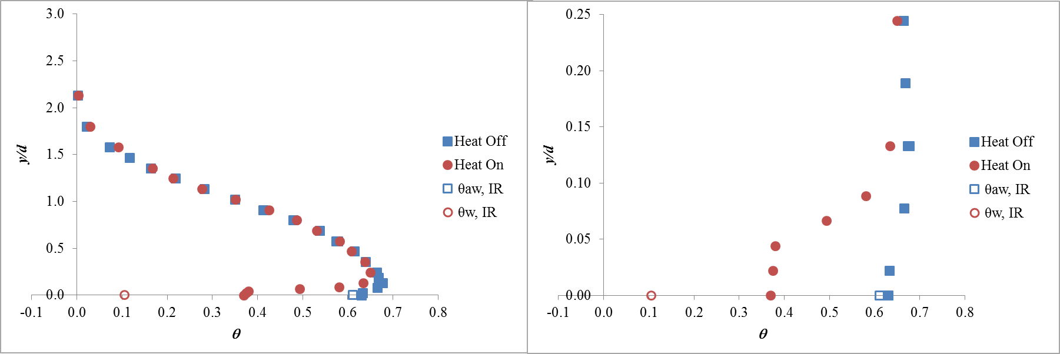
Furthermore, I have begun similar thermal boundary layer measurements to those of [6], with slightly different freestream conditions, yet have been unable to reproduce the correspondence between T_{w} and T_{aw} that was predicted by the correction scheme. Despite careful checks of the experimental uncertainty and analytical assumptions made, it is unclear why this is the case.
Figure 14: Thermal profile at jet centerline for DR = 1.2, M = 2.0 at x/D = 5, with magnified scale on right side. Agreement between thermal probe measurements (solid symbols) and IR camera measurements (open symbols) was good for the unheated wall (blue) but poor for the heated wall (red). Data from [6].

Expected Contribution and Methods
The goal of this work is to develop a method for radiation and conduction error correction in film cooling measurements, and to further validate the method to reduce correction uncertainty.
The above discussion seems to lead toward two possibilities: first, the measurements made thus far may not accurately measure the temperature differences or resolve the profile of the thermal boundary layer sufficiently; and second, that the formulation of the conduction correction is inaccurate or incomplete. Experimental uncertainties and ambiguities make it difficult to investigate further without additional data. Thus the following experiments and analyses are proposed to better understand thermal errors:
- Thermal boundary layer measurements at different lateral and downstream locations to investigate the existence of a thermal boundary layer, both within the coolant jet and in the approaching flow
- Evaluation of different 3D conduction corrections, which can come from commercial codes or relatively simple in-house codes
- Experiments to validate the 3D conduction correction. This may include using two materials with different thermal conductivities for the flat plate, and then comparing the predicted conduction correction, along with embedded thermocouple measurements to provide accurate boundary conditions
- Experiments to validate the radiation correction. This may include operating the wind tunnel at two different freestream temperatures, or reducing the radiation loading of the flat plate by lower the emissivity of the wind tunnel ceiling (the extant acrylic ceiling has an emissivity of approximately ε = 0.98)
- Spatially-resolved measurements of the heat transfer coefficient h_{f}
The result of this investigation will be a well-understood method for removing the effects of conduction and radiation in film cooling experiments, which should be generalizable to geometries and configurations beyond just a flat plate.

Work Completed
This work obviously requires efforts to not only acquire accurate thermal measurements, but also investigate prediction methods for conductive heat transfer and radiation. Work has begun on both fronts.
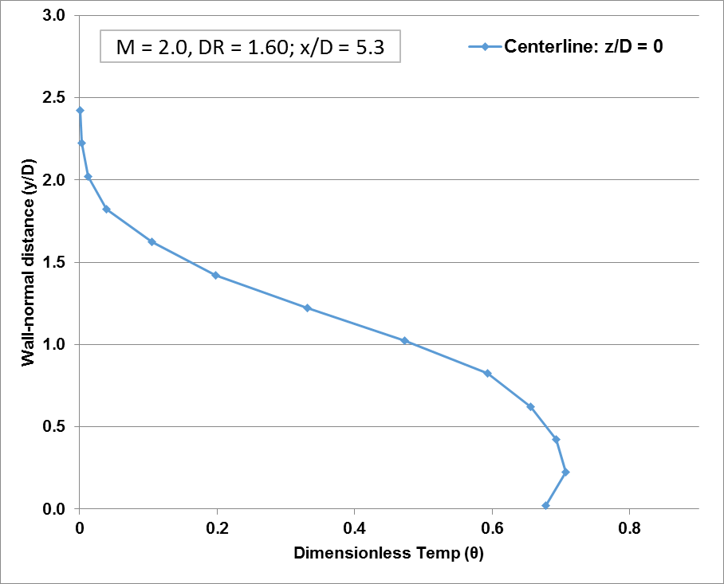
Thermal Field Measurements: Measurements with a fine-wire thermocouple have begun in an effort to understand the necessary conduction corrections. The first test case considered was the coolant flow downstream of a shaped cooling hole, at M = 2.0 and DR = 1.6. The adiabatic effectiveness was measured with an IR camera, and a d_{p} = 0.001” (0.025mm) Type-E thermocouple probe was used to measure the temperature field above the surface. The measurement at x/D = 5.3 is shown below in Figure 15. The purpose of this particular measurement was to study the off-wall structure of the coolant jet, rather than investigate a thermal boundary layer. However, very little evidence of this thermal boundary layer is visible in this measurement. Again, more finely-resolved measurement of the temperature field above the surface is needed. The uncertainty in the position in the probe was about δy = 0.1 mm, which may have prevented resolution of the thermal boundary layer if it were thinner than this.
Figure 15: Centerline thermal profile for M = 2.0, DR = 1.60, x/D = 5.3.
Δθ = 0.03
Heat Transfer Analysis: Analysis of the heat transfer problem and development of a correction procedure has begun, utilizing an in-house Matlab script to solve for the temperature distribution in the flat plate. Currently, only a 2-dimensional solver is used since the temp gradients in the lateral direction are far stronger than in the streamwise direction. This obviously introduces some yet-to-be-quantified error in the results. Preliminary results indicate a significant correction to the peak effectiveness, approximately Δη = 0.12, as shown in Figure 16.
This is strongly at odds with the thermal field results shown above in Figure 15, which indicated only Δη = 0.03 (by measuring Δθ = 0.03). If the thermal field measurements and heat transfer analysis were consistent, the difference between the wall temp and coldest temp within the thermal boundary layer should be close to that of the implied correction to the adiabatic effectiveness. This does not appear to be the case.
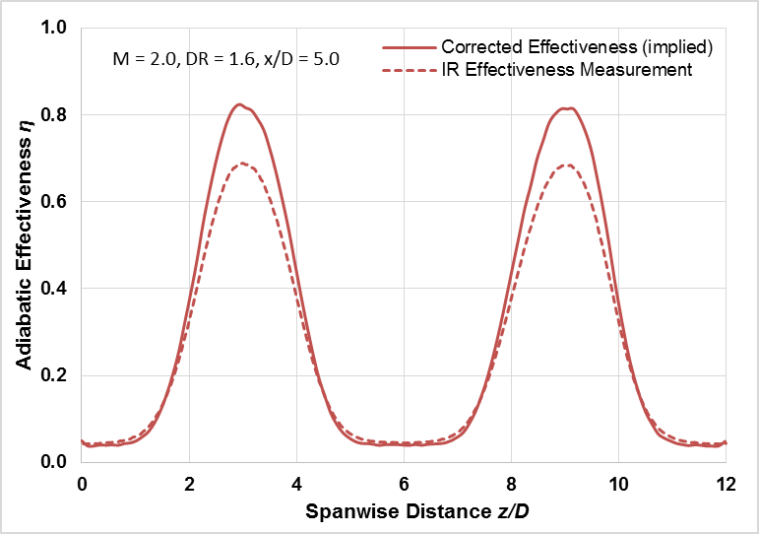
Figure 16: Lateral adiabatic effectiveness distribution at x/D = 5.0, with uncorrected (dashed) and corrected (solid) distributions shown.

Remaining Analysis and Experiments
The remaining tasks are somewhat loosely categorized at this point, and we expect to learn more and develop a more detailed plan in the coming weeks. The following list gives a rough idea of what work remains:
- Perform additional thermal boundary layer measurements; perform analysis to determine expected thermal boundary layer thickness
- Test effectiveness with two different flat-plate materials
  - Examines: Accuracy of FEA heat flux solver
- Test effectiveness with two different tunnel temperatures
  - Examines: Accuracy of radiation correction
- Perform spatially-resolved h_{f} measurements at exactly known conditions (will be measured in parallel with h_{f} for Proposal Objective #2).
  - Improves overall correction accuracy

Experimental Plan and Timeline:
The following timeline gives a rough estimate of the time needed to complete the above tasks:
Objective | Experiments Needed | Time to Complete | Publication
1: Density Ratio Effects | Effectiveness: 1  Thermal Fields: 3 | 4 weeks | Direct to Journal of Turbomachinery
2: Freestream Effects | Effectiveness: 1  HTC Augmentation: 3  Thermal Fields: 3  Velocity Fields: 1 | 6 weeks | ASME Conference: IGTI 2017
3: Measurement Analysis | Effectiveness: 3  HTC Augmentation: 1  Thermal Fields: 1 | 10 weeks | ASME Conference: IGTI 2017
Write Everything Up |  | 10 weeks

Target Graduate Date: May 2017

References

[1] | M. Moran and M. Shapiro, Fundamentals of Engineering Thermodynamics, New York: Wiley, 2006.
[2] | B. Koff, "Gas Turbine Technology Overview - A Designer's Perspective," in AIAA/ICAS International Air and Space Symposium and Exposition: The Next 100 Years, Dayton, Ohio, 2003.
[3] | B. Haven, D. Yamagata and M. Kurosaka, "Anti-Kidney Pair of Vortices in Shaped Holes and Their Influence on Film Cooling Effectiveness," in Proceedings of the IGTI Turbo Expo, Orlando, FL, USA, 1997.
[4] | D. Bogard and K. Thole, "Gas Turbine Film Cooling," Journal of Propulsion and Power, vol. 22, no. 2, pp. 249-270, 2006.
[5] | E. Eckert, "Gas-to-Gas Film Cooling," Journal of Engineering Physics, vol. 19, no. 3, pp. 1091-1101, 1970.
[6] | E. Boyd, "Parameters that Affect Shaped Hole Film Cooling Performance andthe Effect of Density Ratio on Heat Transfer Coefficient Augmentation," PhD Dissertation, The University of Texas at Austin, Austin, Texas, 2014.
[7] | J. Dittmar, A. Schulz and S. Wittig, "Adiabatic Effectiveness and Heat Transfer Coefficient of Shaped Film Cooling Holes on a Scaled Guide Vane Pressure Side Model," International Journal of Rotating Machinery, vol. 10, no. 5, pp. 345-354, 2004.
[8] | K. Harrison, J. Dorrington, J. E. Dees, D. G. Bogard and R. Bunker, "Turbine Airfoil Net Heat Flux Reduction With Cylindrical Holes Embedded in a Transverse Trench," J. Turbomach, vol. 131, no. 1, pp. 011012-1-8, 2009.
[9] | C. Saumweber, A. Schulz and S. Wittig, "Free-Stream Turbulence Effects on Film Cooling with Shaped Holes," J. Turbomach, vol. 125, no. 1, pp. 65-73, 2003.
[10] | C. Liu, H. Zhu, A. Wu and Y. N. Zhai, "Experimental Investigation of the Influence of Inclination Angle on the Film Cooling Performance of Diffuser Shaped Holes," in Proceedings of the ASME Turbo Expo 2016: Technical Conference and Exposition, Seoul, South Korea, 2016.
[11] | R. Schroeder and K. Thole, "Adiabatic Effectiveness Measurements for a Baseline Shaped Film Cooling Hole," in Proceedings of the ASME Turbo Expo 2014: Technical Conference and Exposition, Dusseldorf, 2014.
[12] | J. Anderson, E. Boyd and D. Bogard, "Experimental Investigation of Coolant-t-Mainstream Scaling Parameters with Cylindrical and Shaped Film Cooling Holes," in Proceedings of the ASME Turbo Expo 2015: Turbine Technical Conference and Exposition, Montreal, Canada, 2015.
[13] | T. Watson, S. Nahanh-Toudeshki, L. Wright, D. Crites, M. Morris and A. Riahi, "Application of S-PIV For Investigation of Round And Shaped Film Cooling Holes at Hi Density Ratios," in Proceedings of the ASME Turbo Expo 2016: Turbomachinery Technical Conference and Exposition, 2016.
[14] | C. Liess, "Experimental Investigation of Film Cooling With Ejection From a Row of Holes for the Application to Gas Turbine Blades," Journal of Engineering for Power, vol. January, pp. 21-27, 1975.
[15] | C. Saumweber and A. Schulz, "Free-Stream Effects on the Cooling Performance of Cylindrical and Fan-Shaped Cooling Holes," J. Turbomach, vol. 134, no. November, pp. 061007-1-12, 2012.
[16] | R. Goldstein and T. Yoshida, "The Influence of a Laminar Boundary Layer and Laminar Injection on Film Cooling Performance," Journal of Heat Transfer, vol. 104, no. May, pp. 355-362, 1982.
[17] | K. Kadotani and R. Goldstein, "Effect of Mainstream Variables on Jets Issuing from a Row of Inclined Round Holes," Journal of Engineering for Power, vol. 101, no. 2, pp. 298-304, 1979.
[18] | J. McClintic, T. Dyson, D. Bogard and S. Bradshaw, "Mean and Turbulent Velocity Profile Measurements on the Suction Side of a Film COoled Turbine Vane," in Proceedings of the ASME Turbo Expo 2013: Turbine Technical Conference and Exposition, San Antonio, Texas, USA, 2013.
[19] | F. Ames, "Aspects of Vane Film Cooling with High Turbulence: Part I- Heat Transfer," J. Turbomach, vol. 120, no. 10, pp. 768-776, 1998.
[20] | K. Kadotani and R. Goldstein, "On the Nature of Jets Entering a Turbulent Flow Part B- Film Cooling Performance," Journal of Engineering for Power, vol. 101, no. 7, pp. 466-470, 1979.
[21] | F. Ames, "Aspects of Vane Film Cooling with High Turbulence: Part II- Adiabatic Effectiveness," J. Turbomach, vol. 120, pp. 777-784, 2998.
[22] | R. Schroeder and K. Thole, "Effect of High Freestream Turbulence on Flowfields of Shaped Film Cooling Holes," J. Turbomach, vol. 138, no. 9, pp. 091001-1-10, 2016.
[23] | R. Radomsky and K. Thole, "Flowfield Measurements for a Highly Turbulent Flow in a Stator Vane Passage," J. Turbomach, vol. 122, no. 4, pp. 255-262, 2000.
[24] | J. Kingery and F. Ames, "Full-Coverage Shaped Hole Film Cooling in an Accelerating Boundary Layer with Hi Freestream Turbulence," J. Turbomach, vol. 138, no. 7, pp. 071002-1 - 12, 2016.
[25] | J. Han and A. Rallabandi, "Turbine Blade Cooldin Using PSP Technique," Frontiers in Heat and Mass Transfer, vol. 1, 2010.
[26] | D. Robertson, "Roughness Impact on Turbine Vane Suction Side Film Cooling Effectiveness," Master's Thesis, The University of Texas at Austin, 2004.
[27] | J. W. McClintic, S. R. Klavetter, J. B. Anderson, J. R. Winka, D. G. Bogard, J. E. Dees, G. M. Laskowski and R. Briggs, "The Effect of Internal Cross-Flow on the Adiabatic Effectiveness of Compound Angle Film Cooling Holes," in Proceedings of the ASME Turbo Expo 2014, Dusseldorf, Germany, 2014.
[28] | J. Cutbirth and D. Bogard, "Evaluation of Pressure Side Filim Cooling with Flow and Thermal Field Measurements- Part I," J. Turbomach, vol. 124, pp. 670-677, 2002.
[29] | R. Bunker, "A Review of Shaped Hole Turbine Film Cooling Technology," Journal of Heat Transfer, vol. 127, no. April, pp. 441-453, 205.

Appendix A: Completed Coursework

All graduate coursework taken (All from UT-Austin):
Course | Instructor | MS/PhD | Date
Incompressible Fluid Mechanics | Bogard | MS | Fall 11
Advanced Thermodynamics | Berberoglu | MS | Fall 11
Engineering Analysis | Demkowicz | MS | Fall 11
Intermediate Heat Transfer | Ezekoye | MS | Spr. 12
Combustion Engine Processes | Matthews | MS | Spr. 12
Adv. Experimental Methods | Bogard | MS | Fall 12
Modeling of Physical Systems | Longoria | MS | Fall 12
Dynamics of Turbulent Flow | Moser | MS (CR/NC) | Spr. 13
Energy Technology & Policy | Webber | PhD | Spr. 12
Radiation Heat Transfer | Shi | PhD | Fall 13
Adv. Problems Compressible Flow | Raja | PhD | Spr. 14
Computational Fluid Dynamics | Raman | PhD | Spr. 14
Convective Heat and Mass Transfer | Ezekoye | PhD | Spr. 15
Advanced Combustion | Ezekoye | PhD | Spr. 16
Validation and Uncertainty Quant. | Moser | (CR/NC) | Spr. 16

Total Graded Hours: 39 (21 MS + 18 PhD)
Total Coursework Hours: 45
Date of MSE Graduation: December 2013
Master’s Advisor: Dr. David Bogard
Passed Qualifying Examination: August 2014

Appendix B: Publications

ASME Journal of Turbomachinery Articles
- Winka, J., Anderson, J., Boyd, E., Bogard, D., Crawford, M., 2013, “Convex Curvature Effects on Film Cooling Adiabatic Effectiveness,” J. Turbomach, vol 136, no 6, pp 061015-1-9

- Anderson, J., Winka, J., Bogard, D., Crawford, M., 2014, “Evaluations of Superposition Predictions for Showerhead Film Cooling on a Vane,” J. Turbomach, vol. 137, no 4, pp 041010-1-10

- McClintic, J., Klavetter, S., Anderson, J., Winka, J., Bogard, D., Dees, J., Laskowski, G., and Briggs, R., 2014, "The Effect of Internal Cross-Flow on the Adiabatic Effectiveness of Compound Angle Film Cooling Holes," J. Turbomach, vol. 137, no 7, pp 071006-1-10

ASME Peer-Reviewed Conference Proceedings
- Anderson, J., Wilkes, E., McClintic, J., and Bogard, D., 2016, "Effects of Freestream Mach number, Reynolds number, and Boundary Layer Thickness on Film Cooling Effectiveness of Shaped Holes," in Proceedings of the ASME Turbo Expo 2016: Turbine Technical Conference and Exposition, ASME Paper GT2016-56152. Seoul, South Korea

- Wilkes, E., Anderson, J., McClintic, J., and Bogard, D., 2016, "Experimental Investigation of Coolant-t-Mainstream Scaling Parameters with Cylindrical and Shaped Film Cooling Holes," in Proceedings of the ASME Turbo Expo 2016: Turbine Technical Conference and Exposition, ASME Paper GT2016-56162. Seoul, South Korea

- Anderson, J., Boyd, E., and Bogard, D., 2015, "Experimental Investigation of Coolant-to-Mainstream Scaling Parameters with Cylindrical and Shaped Film Cooling Holes," in Proceedings of the ASME Turbo Expo 2015: Turbine Technical Conference and Exposition, ASME Paper GT2015-43072. Montreal, Canada.

- McClintic, J., Kistenmacher, D., Anderson, J., Demrier, O., Berberoglu, H., 2012, “A Thermodynamic Analysis of a Solar Organic Rankine Cycle,” in Proceedings of the ASME 2012 International Mechanical Engineering Congress and Exposition, ASME Paper IMECE2012-88404, Houston, Texas, USA

